43.18: a) As in the example, (0.000898 u)(931.5 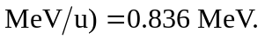
b)

